These are the questions that i might ask:  
1) What is the control flow  
2) what is a data flow  
3) how do you do error handling in SSIS  
4) how do you do logging in ssis  
5) how do you deploy ssis packages.  
6) how do you schedule ssis packages to run on the fly  
7) how do you run stored procedure and get data  
8) give a scenario: Want to insert a tect file into database table, but during the upload want to  
change a column called as months - January, Feb, etc to a code, - 1,2,3.. .This code can be read  
from another database table called months. After the conversion of the data , upload the file. If  
there are any errors, write to error table. Then for all errors, read errors from database, create a  
file, and mail it to the supervisor.  
How would you accomplish this task in SSIS?  
9)what are variables and what is variable scope ?

Answers  
For Q 1 and 2:  
In SSIS a workflow is called a control-flow. A control-flow links together our modular data-flows as a  
series of operations in order to achieve a desired result.

A control flow consists of one or more tasks and containers that execute when the package runs. To  
control order or define the conditions for running the next task or container in the package control flow,  
you use precedence constraints to connect the tasks and containers in a package. A subset of tasks  
and containers can also be grouped and run repeatedly as a unit within the package control flow.

SQL Server 2005 Integration Services (SSIS) provides three different types of control flow elements:  
containers that provide structures in packages, tasks that provide functionality, and precedence  
constraints that connect the executables, containers, and tasks into an ordered control flow.

A data flow consists of the sources and destinations that extract and load data, the transformations  
that modify and extend data, and the paths that link sources, transformations, and destinations. Before  
you can add a data flow to a package, the package control flow must include a Data Flow task. The  
Data Flow task is the executable within the SSIS package that creates, orders, and runs the data flow.  
A separate instance of the data flow engine is opened for each Data Flow task in a package.

SQL Server 2005 Integration Services (SSIS) provides three different types of data flow components:  
sources, transformations, and destinations. Sources extract data from data stores such as tables and  
views in relational databases, files, and Analysis Services databases. Transformations modify,  
summarize, and clean data. Destinations load data into data stores or create in-memory datasets.  
Q3:  
When a data flow component applies a transformation to column data, extracts data from sources, or  
loads data into destinations, errors can occur. Errors frequently occur because of unexpected data  
values.

For example, a data conversion fails because a column contains a string instead of a number, an  
insertion into a database column fails because the data is a date and the column has a numeric data  
type, or an expression fails to evaluate because a column value is zero, resulting in a mathematical  
operation that is not valid.

Errors typically fall into one the following categories:

-Data conversion errors, which occur if a conversion results in loss of significant digits, the loss of  
insignificant digits, and the truncation of strings. Data conversion errors also occur if the requested  
conversion is not supported.  
-Expression evaluation errors, which occur if expressions that are evaluated at run time perform invalid  
operations or become syntactically incorrect because of missing or incorrect data values.  
-Lookup errors, which occur if a lookup operation fails to locate a match in the lookup table.

Many data flow components support error outputs, which let you control how the component handles row-level errors in both incoming and outgoing data. You specify how the component behaves when truncation or an error occurs by setting options on individual columns in the input or output.

For example, you can specify that the component should fail if customer name data is truncated, but

ignore errors on another column that contains less important data.

Q 4:  
SSIS includes logging features that write log entries when run-time events occur and can also write  
custom messages.

Integration Services supports a diverse set of log providers, and gives you the ability to create custom  
log providers. The Integration Services log providers can write log entries to text files, SQL Server  
Profiler, SQL Server, Windows Event Log, or XML files.

Logs are associated with packages and are configured at the package level. Each task or container in  
a package can log information to any package log. The tasks and containers in a package can be  
enabled for logging even if the package itself is not.

To customize the logging of an event or custom message, Integration Services provides a schema of commonly logged information to include in log entries. The Integration Services log schema defines the information that you can log. You can select elements from the log schema for each log entry.

To enable logging in a package  
1. In Business Intelligence Development Studio, open the Integration Services project that contains the  
package you want.  
2. On the SSIS menu, click Logging.  
3. Select a log provider in the Provider type list, and then click Add.

Q 5:

SQL Server 2005 Integration Services (SSIS) makes it simple to deploy packages to any computer.  
There are two steps in the package deployment process:  
-The first step is to build the Integration Services project to create a package deployment utility.  
-The second step is to copy the deployment folder that was created when you built the Integration  
Services project to the target computer, and then run the Package Installation Wizard to install the  
packages.

Q 9:

Variables store values that a SSIS package and its containers, tasks, and event handlers can use at  
run time. The scripts in the Script task and the Script component can also use variables. The  
precedence constraints that sequence tasks and containers into a workflow can use variables when  
their constraint definitions include expressions.

Integration Services supports two types of variables: user-defined variables and system variables.  
User-defined variables are defined by package developers, and system variables are defined by  
Integration Services. You can create as many user-defined variables as a package requires, but you  
cannot create additional system variables.

Scope :

A variable is created within the scope of a package or within the scope of a container, task, or event  
handler in the package. Because the package container is at the top of the container hierarchy,  
variables with package scope function like global variables and can be used by all containers in the  
package. Similarly, variables defined within the scope of a container such as a For Loop container can  
be used by all tasks or containers within the For Loop container.

Tell me about your experience with SSIS

•

I think some experience that may stand out from the rest may include (A bit more

advanced):

Debugging Packages: Setting break points, using dataviews, running SQL profiler  
Creating custom configurations: XML and DB  
Deployment Strategies  
Custom Logging  
Running control flow and data flow in Transactions

•

Multicast transformation - The Multicast transformation distributes its input to one or more  
outputs. This transformation is similar to the Conditional Split transformation. Both  
transformations direct an input to multiple outputs. The difference between the two is that  
the Multicast transformation directs every row to every output, and the Conditional Split  
directs a row to a single output

Question 1 - True or False - Using a checkpoint file in SSIS is just like issuing the CHECKPOINT  
command against the relational engine. It commits all of the data to thedatabase.  
False. SSIS provides a Checkpoint capability which allows a package to restart at the point of  
failure.

Question 2 - Can you explain the what the Import\Export tool does and the basic steps in the  
wizard?  
The Import\Export tool is accessible via BIDS or executing the dtswizard command.  
The tool identifies a data source and a destination to move data either within 1 database,  
between instances or even from a database to a file (or vice versa).

Question 3 - What are the command line tools to execute SQL Server Integration Services  
packages?  
DTSEXECUI - When this command line tool is run a user interface is loaded in order to configure  
each of the applicable parameters to execute anSSIS package.  
DTEXEC - This is a pure command line tool where all of the needed switches must be passed  
into the command for successful execution of the SSIS package.

Question 4 - Can you explain the SQL Server Integration Services functionality in Management  
Studio?  
You have the ability to do the following:  
Login to the SQL Server Integration Services instance  
View the SSIS log  
View the packages that are currently running on that instance  
Browse the packages stored in MSDB or the file system  
Import or export packages  
Delete packages  
Run packages

Question 5 - Can you name some of the core SSIS components in the Business Intelligence  
Development Studio you work with on a regular basis when building an SSIS package?  
Connection Managers  
Control Flow  
Data Flow  
Event Handlers  
Variables window  
Toolbox window  
Output window

Logging

Package Configurations  
Question Difficulty = Moderate  
Question 1 - True or False: SSIS has a default means to log all records updated, deleted or

inserted on a per table basis.

False, but a custom solution can be built to meet these needs.

Question 2 - What is a breakpoint in SSIS? How is it setup? How do you disable it?  
A breakpoint is a stopping point in the code. The breakpoint can give the Developer\DBA an  
opportunity to review the status of the data, variables and the overall status of the SSIS package.  
10 unique conditions exist for each breakpoint.  
Breakpoints are setup in BIDS. In BIDS, navigate to the control flow interface. Right click on the  
object where you want to set the breakpoint and select the 'Edit Breakpoints...' option.

Question 3 - Can you name 5 or more of the native SSIS connection managers?

OLEDB connection - Used to connect to any data source requiring an OLEDB connection (i.e.,

SQL Server 2000)

Flat file connection - Used to make a connection to a single file in the File System. Required for  
reading information from a File System flat file  
ADO.Net connection - Uses the .Net Provider to make a connection to SQL Server 2005 or other  
connection exposed through managed code (like C#) in a custom task  
Analysis Services connection - Used to make a connection to an Analysis Services database or  
project. Required for the Analysis Services DDL Task and Analysis Services Processing Task  
File connection - Used to reference a file or folder. The options are to either use or create a file or  
folder  
Excel  
FTP  
HTTP  
MSMQ  
SMO  
SMTP  
SQLMobile

WMI

Question 4 - How do you eliminate quotes from being uploaded from a flat file to SQL Server?  
In the SSIS package on the Flat File Connection Manager Editor, enter quotes into the Text  
qualifier field then preview the data to ensure the quotes are not included.  
Additional information: How to strip out double quotes from an import file in SQL Server  
Integration Services  
Question 5 - Can you name 5 or more of the main SSIS tool boxwidgets and their functionality?  
For Loop Container  
Foreach Loop Container  
Sequence Container  
ActiveX Script Task  
Analysis Services Execute DDL Task  
Analysis Services Processing Task  
Bulk Insert Task  
Data Flow Task

Data Mining Query Task

Execute DTS 2000 Package Task  
Execute Package Task  
Execute Process Task

Execute SQL Task

etc.

Question Difficulty = Difficult

Question 1 - Can you explain one approach to deploy an SSIS package?  
One option is to build a deployment manifest file in BIDS, then copy the directory to the applicable  
SQL Server then work through the steps of the package installation wizard  
A second option is using the dtutil utility to copy, paste, rename, delete an SSIS Package  
A third option is to login to SQL Server Integration Services via SQL Server Management Studio  
then navigate to the 'Stored Packages' folder then right click on the one of the children folders or  
an SSIS package to access the 'Import Packages...' or 'Export Packages...'option.  
A fourth option in BIDS is to navigate to File | Save Copy of Package and complete the interface.

Question 2 - Can you explain how to setup a checkpoint file in SSIS?  
The following items need to be configured on the properties tab for SSIS package:  
CheckpointFileName - Specify the full path to the Checkpoint file that the package uses to save  
the value of package variables and log completed tasks. Rather than using a hard-coded path as  
shown above, it's a good idea to use an expression that concatenates a path defined in a  
package variable and the package name.  
CheckpointUsage - Determines if/how checkpoints are used. Choose from these options: Never  
(default), IfExists, or Always. Never indicates that you are not using Checkpoints. IfExists is the  
typical setting and implements the restart at the point of failure behavior. If a Checkpoint file is  
found it is used to restore package variable values and restart at the point of failure. If a  
Checkpoint file is not found the package starts execution with the first task. The Always choice  
raises an error if the Checkpoint file does not exist.  
SaveCheckpoints - Choose from these options: True or False (default). You must select True to  
implement the Checkpoint behavior.

Question 3 - Can you explain different options for dynamic configurations in SSIS?  
Use an XML file  
Use custom variables  
Use a database per environment with the variables  
Use a centralized database with all variables

Question 4 - How do you upgrade an SSIS Package?  
Depending on the complexity of the package, one or two techniques are typically used:  
Recode the package based on the functionality in SQL Server DTS  
Use the Migrate DTS 2000 Package wizard in BIDS then recode any portion of the package that  
is not accurate

Question 5 - Can you name five of the Perfmon counters for SSIS and the value they provide?  
SQLServer:SSIS Service  
SSIS Package Instances - Total number of simultaneous SSIS Packages running  
SQLServer:SSIS Pipeline  
BLOB bytes read - Total bytes read from binary large objects during the monitoring period.  
BLOB bytes written - Total bytes written to binary large objects during the monitoring period.  
BLOB files in use - Number of binary large objects files used during the data flow task during the  
monitoring period.  
Buffer memory - The amount of physical or virtual memory used by the data flow task during the  
monitoring period.  
Buffers in use - The number of buffers in use during the data flow task during the monitoring  
period.

Buffers spooled - The number of buffers written to disk during the data flow task during the  
monitoring period.  
Flat buffer memory - The total number of blocks of memory in use by the data flow task during the  
monitoring period.  
Flat buffers in use - The number of blocks of memory in use by the data flow task at a point in  
time.  
Private buffer memory - The total amount of physical or virtual memory used by data  
transformation tasks in the data flow engine during the monitoring period.  
Private buffers in use - The number of blocks of memory in use by the transformations in the data  
flow task at a point in time.  
Rows read - Total number of input rows in use by the data flow task at a point in time.  
Rows written - Total number of output rows in use by the data flow task at a point in time.

1. What does a control flow do?  
2. Generically explain what happens inside a data flow task?  
3. Explain what ETL is?  
4. Which task would you use to copy, move or delete files?  
5. Which transform would you use to split your data based on

conditions you define?

6. Explain the pros and cons of deploying to a file system vs msdb?

Q1 Explain architecture of SSIS?

http://technet.microsoft.com/en-us/library/ms141709(SQL.90).aspx

Q2 Difference between Control Flow and Data Flow?

Very easy.

Q3 How would you do Logging in SSIS?

Log using the logging configuration inbuilt in SSIS or use Custom logging through Event

handlers. http://msdn.microsoft.com/en-us/library/ms141727.aspx

Q4 How would you do Error Handling?

its for you.

Q5 How to pass property value at Run time? How do you implement Package Configuration?

http://msdn.microsoft.com/en-us/library/ms141682.aspx

Q6 How would you deploy a SSIS Package on production?

1. Create deployment utility by setting its propery as true .

2. It will be created in the bin folder of the solution as soon as package is build.

3. Copy all the files in the utility and use manifest file to deply it on the Prod.

Q7 Difference between DTS and SSIS?

Every thing except both are product of Microsoft :-)

Q8 What are new features in SSIS 2008?

http://sqlserversolutions.blogspot.com/2009/01/new-improvementfeatures-in-ssis-2008.html

Q9 How would you pass a variable value to Child Package?



http://sqlserversolutions.blogspot.com/2009/02/passing-variable-to-child-package-from.html

http://technet.microsoft.com/en-us/library/ms345179(SQL.90).aspx

Q10 What is Execution Tree?

http://technet.microsoft.com/en-us/library/cc966529.aspx

Q11 What are the points to keep in mind for performance improvement of the package?

http://technet.microsoft.com/en-us/library/cc966529.aspx

Q12 You may get a question stating a scenario and then asking you how would you create a package for  
that e.g. How would you configure a data flow task so that it can transfer data to different table based on the  
city name in a source table column?

Q13 Difference between Unionall and Merge Join?

http://sqlserversolutions.blogspot.com/2009/01/difference-between-merge-and-union-all.html

Q14 May get question regarding what X transformation do?Lookup, fuzzy lookup, fuzzy grouping

transformation are my favorites.

For you.

Q15 How would you restart package from previous failure point?What are Checkpoints and how can we

implement in SSIS?

http://msdn.microsoft.com/en-us/library/ms140226.aspx

Q16 Where are SSIS package stored in the SQL Server?

MSDB.sysdtspackages90 stores the actual content and ssydtscategories, sysdtslog90,

sysdtspackagefolders90, sysdtspackagelog, sysdtssteplog, and sysdtstasklog do the

supporting roles.

Q17 How would you schedule a SSIS packages?

Using SQL Server Agent. Read about Scheduling a job on Sql server Agent

Q18 Difference between asynchronous and synchronos transformations?

Asynchronous transformation have different Input and Output buffers and it is up to the component designer  
in an Async component to provide a column structure to the output buffer and hook up the data from the  
input.

Q19 How to achieve multiple threading in SSIS?

Passing variable to Child package from Parent package in SSIS

Posted by Rahul Kumar at Wednesday, February 25, 2009

Very frequent Question which looks so complicated to programmers.

Actually passing a variable value to a child package is very trivial task. We can pass on the  
value by configuring parent variable in package configuration but there is an easy way of  
achieve this and the fact lies beneath the fundamental principle of Variable Scope.

If you call a Child package then it is like a container itself and all the variables defined in

above hierarchy will be accessible in the Child package.

Let me show this with an example in which I will declare a variable "ParentVar" in my parent

package and call a Child package which will access "ParentVar" and display in a msgbox.

1. Parent: Create Parent Package and declare a variable "ParentVar"

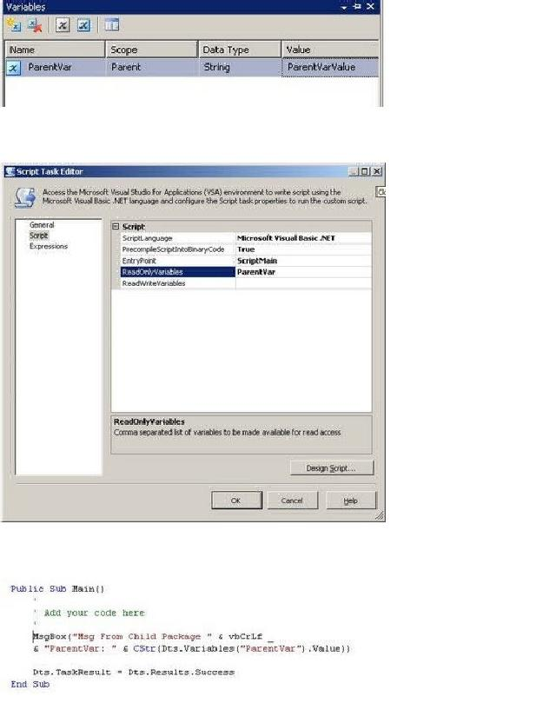

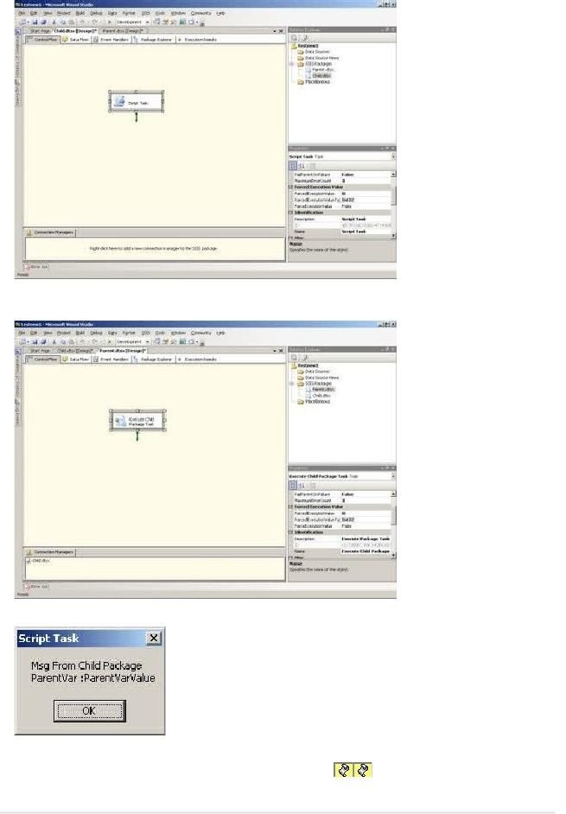

•

Passing variable to Child package from Parent package in SSIS

•

SSIS Interview Questions

•

Copy/Rename a file using File System Task in SSIS

•

Column length in Excel source

Related Posts Widget [?]

Copy/Rename a file using File System Task in SSIS

Posted by Rahul Kumar at Tuesday, April 21, 2009

This is a reference answer to a post on MSDN forum but is very useful

Question: While copying and renaming a file to a dynamic location through File System

Task using variable throws an error

Error: Failed to lock variable "c:\test\test_200904202009.txt" for read  
access with error 0xC0010001 "The variable cannot be found. This  
occurs when an attempt is made to retrieve a variable from the  
Variables collection on a container during execution of the package,  
and the variable is not there. The variable name may have changed or  
the variable is not being created.".OR

How to copy and rename a file to a dynamic location using SSIS?

Solution:

I will move and rename a file "test.txt" from c:\ to c:\backup with new name appended with

date.

1) Create three variables

Src_File = c:\test.txt  
Dest_File = test  
Dest_Dir = c:\backup

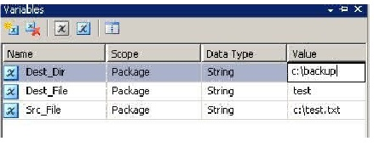

2) In connection Manager create a File Connection with name as DestinationConn

3) In Expression property of DestinationConn use ConnectionString and

provide following expression

@[Dest_Dir] + "\\" + @[Dest_File] + "_" +  
(DT_WSTR,4)DatePart("yyyy", GetDate()) + RIGHT("0" +  
(DT_WSTR,2)DatePart("mm", GetDate()), 2) + RIGHT("0" +  
(DT_WSTR,2)DatePart("dd", GetDate()), 2) + RIGHT("0" +  
(DT_WSTR,2)DatePart("hh", GetDate()), 2) + RIGHT("0" +  
(DT_WSTR,2)DatePart("mi", GetDate()), 2) + ".txt"

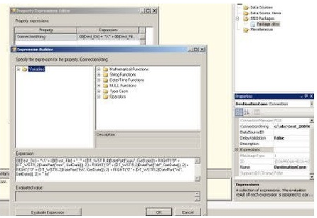

this will set the destination path and new name for the file

4) Create a File System task and configure like :

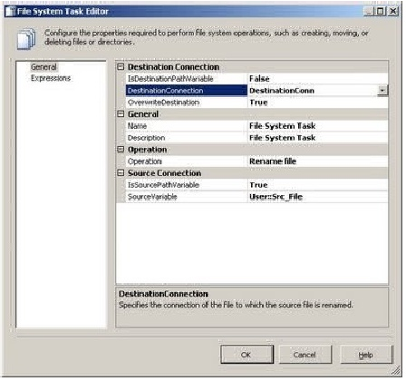

5) Execute the package

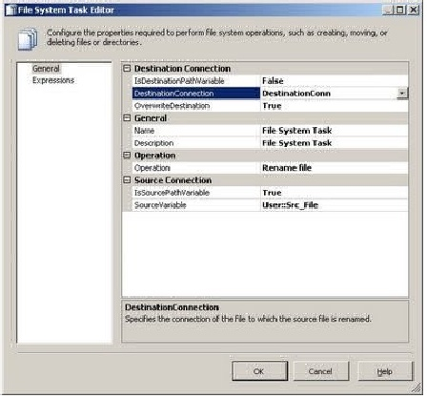

MS SQL Server interview questions

Byadmin | November 3, 2004

This one always gets asked. For a while the database interview questions were limited to Oracle and generic database design questions. This is a set of more than a hundred Microsoft SQL Server interview questions. Some questions are open-ended, and some do not have answers.

1. What is normalization? - Well a relational database is basically composed of tables that contain  
related data. So the Process of organizing this data into tables is actually referred to as  
normalization.

2.What is a Stored Procedure? - Its nothing but a set of T-SQL statements combined to perform a

single task of several tasks. Its basically like a Macro so when you invoke the Stored procedure,

you actually run a set of statements.

3. Can you give an example of Stored Procedure? - sp_helpdb , sp_who2, sp_renamedb are a set of system defined stored procedures. We can also have user defined stored procedures which can be called in similar way.

4. What is a trigger? - Triggers are basically used to implement business rules. Triggers is also similar to stored procedures. The difference is that it can be activated when data is added or edited or deleted from a table in a database.

5. What is a view? - If we have several tables in a db and we want to view only specific columns from specific tables we can go for views. It would also suffice the needs of security some times allowing specfic users to see only specific columns based on the permission that we can configure on the view. Views also reduce the effort that is required for writing queries to access specific columns every time.

6. What is an Index? - When queries are run against a db, an index on that db basically helps in the way the data is sorted to process the query for faster and data retrievals are much faster when we have an index.

7.What are the types of indexes available with SQL Server? - There are basically two types of

indexes that we use with the SQL Server. Clustered and the Non-Clustered.

8.What is the basic difference between clustered and a non-clustered index? - The difference is that,

Clustered index is unique for any given table and we can have only one clustered index on a table.  
The leaf level of a clustered index is the actual data and the data is resorted in case of clustered  
index. Whereas in case of non-clustered index the leaf level is actually a pointer to the data in  
rows so we can have as many non-clustered indexes as we can on the db.

9. What are cursors? - Well cursors help us to do an operation on a set of data that we retreive by commands such as Select columns from table. For example : If we have duplicate records in a table we can remove it by declaring a cursor which would check the records during retreival one by one and remove rows which have duplicate values.

10. When do we use the UPDATE_STATISTICS command? - This command is basically used when we do a large processing of data. If we do a large amount of deletions any modification or Bulk Copy into the tables, we need to basically update the indexes to take these changes into account. UPDATE_STATISTICS updates the indexes on these tables accordingly.

11. Which TCP/IP port does SQL Server run on? - SQL Server runs on port 1433 but we can also

change it for better security.

12. From where can you change the default port? - From the Network Utility TCP/IP properties –>

Port number.both on client and the server.

13. Can you tell me the difference between DELETE & TRUNCATE commands? - Delete command  
removes the rows from a table based on the condition that we provide with a WHERE clause.  
Truncate will actually remove all the rows from a table and there will be no data in the table after  
we run the truncate command.

14. Can we use Truncate command on a table which is referenced by FOREIGN KEY? - No. We

cannot use Truncate command on a table with Foreign Key because of referential integrity.

15. What is the use of DBCC commands? - DBCC stands for database consistency checker. We use  
these commands to check the consistency of the databases, i.e., maintenance, validation task and  
status checks.

16. Can you give me some DBCC command options?(Database consistency check) - DBCC CHECKDB - Ensures that tables in the db and the indexes are correctly linked.and DBCC CHECKALLOC - To check that all pages in a db are correctly allocated. DBCC SQLPERF - It gives report on current usage of transaction log in percentage. DBCC CHECKFILEGROUP - Checks all tables file group for any damage.

17. What command do we use to rename a db? - sp_renamedb ‘oldname’ , ‘newname’

18. Well sometimes sp_reanmedb may not work you know because if some one is using the db it will not accept this command so what do you think you can do in such cases? - In such cases we can first bring to db to single user using sp_dboptions and then we can rename that db and then we can rerun the sp_dboptions command to remove the single user mode.

19. What is the difference between a HAVING CLAUSE and a WHERE CLAUSE? - Having Clause is  
basically used only with the GROUP BY function in a query. WHERE Clause is applied to each  
row before they are part of the GROUP BY function in a query.

20. What do you mean by COLLATION? - Collation is basically the sort order. There are three types

of sort order Dictionary case sensitive, Dictonary - case insensitive and Binary.

21. What is a Join in SQL Server? - Join actually puts data from two or more tables into a single

result set.

22. Can you explain the types of Joins that we can have with Sql Server? - There are three types of

joins: Inner Join, Outer Join, Cross Join

23.When do you use SQL Profiler? - SQL Profiler utility allows us to basically track connections to

the SQL Server and also determine activities such as which SQL Scripts are running, failed jobs

etc..

24.What is a Linked Server? - Linked Servers is a concept in SQL Server by which we can add other

SQL Server to a Group and query both the SQL Server dbs using T-SQL Statements.

25. Can you link only other SQL Servers or any database servers such as Oracle? - We can link any  
server provided we have the OLE-DB provider from Microsoft to allow a link. For Oracle we have  
a OLE-DB provider for oracle that microsoft provides to add it as a linked server to the sql server  
group.

26.Which stored procedure will you be running to add a linked server? -sp_addlinkedserver,

sp_addlinkedsrvlogin

27. What are the OS services that the SQL Server installation adds? - MS SQL SERVER SERVICE,

SQL AGENT SERVICE, DTC (Distribution transac co-ordinator)

28. Can you explain the role of each service? - SQL SERVER - is for running the databases SQL AGENT - is for automation such as Jobs, DB Maintanance, Backups DTC - Is for linking and connecting to other SQL Servers

29. How do you troubleshoot SQL Server if its running very slow? - First check the processor and  
memory usage to see that processor is not above 80% utilization and memory not above 40-45%  
utilization then check the disk utilization using Performance Monitor, Secondly, use SQL Profiler  
to check for the users and current SQL activities and jobs running which might be a problem.  
Third would be to run UPDATE_STATISTICS command to update the indexes

30. Lets say due to N/W or Security issues client is not able to connect to server or vice versa. How do  
you troubleshoot? - First I will look to ensure that port settings are proper on server and client  
Network utility for connections. ODBC is properly configured at client end for connection ——  
Makepipe & readpipe are utilities to check for connection. Makepipe is run on Server and  
readpipe on client to check for any connection issues.

31. What are the authentication modes in SQL Server? - Windows mode and mixed mode (SQL &

Windows).

32. Where do you think the users names and passwords will be stored in sql server? - They get stored

in master db in the sysxlogins table.

33.What is log shipping? Can we do logshipping with SQL Server 7.0 - Logshipping is a new feature

of SQL Server 2000. We should have two SQL Server - Enterprise Editions. From Enterprise  
Manager we can configure the logshipping. In logshipping the transactional log file from one  
server is automatically updated into the backup database on the other server. If one server fails,  
the other server will have the same db and we can use this as the DR (disaster recovery) plan.

34. Let us say the SQL Server crashed and you are rebuilding the databases including the master database what procedure to you follow? - For restoring the master db we have to stop the SQL Server first and then from command line we can type SQLSERVER â€“m which will basically bring it into the maintenance mode after which we can restore the master db.

35.Let us say master db itself has no backup. Now you have to rebuild the db so what kind of action

do you take? - (I am not sure- but I think we have a command to do it).

36. What is BCP? When do we use it? - BulkCopy is a tool used to copy huge amount of data from

tables and views. But it won’t copy the structures of the same.

37. What should we do to copy the tables, schema and views from one SQL Server to another? - We

have to write some DTS packages for it.  
38. What are the different types of joins and what dies each do?  
39. What are the four main query statements?

40. What is a sub-query? When would you use one?  
41. What is a NOLOCK?  
42. What are three SQL keywords used to change or set someone’s permissions?  
43. What is the difference between HAVING clause and the WHERE clause?  
44. What is referential integrity? What are the advantages of it?  
45. What is database normalization?  
46. Which command using Query Analyzer will give you the version of SQL server and operating

system?

47. Using query analyzer, name 3 ways you can get an accurate count of the number of records in a

table?  
48. What is the purpose of using COLLATE in a query?  
49. What is a trigger?  
50. What is one of the first things you would do to increase performance of a query? For example, a

boss tells you that “a query that ran yesterday took 30 seconds, but today it takes 6 minutes”  
51. What is an execution plan? When would you use it? How would you view the execution plan?  
52. What is the STUFF function and how does it differ from the REPLACE function?  
53. What does it mean to have quoted_identifier on? What are the implications of having it off?  
54. What are the different types of replication? How are they used?  
55. What is the difference between a local and a global variable?  
56. What is the difference between a Local temporary table and a Global temporary table? How is

each one used?  
57. What are cursors? Name four types of cursors and when each one would be applied?  
58. What is the purpose of UPDATE STATISTICS?  
59. How do you use DBCC statements to monitor various aspects of a SQL server installation?  
60. How do you load large data to the SQL server database?  
61. How do you check the performance of a query and how do you optimize it?  
62. How do SQL server 2000 and XML linked? Can XML be used to access data?  
63. What is SQL server agent?  
64. What is referential integrity and how is it achieved?  
65. What is indexing?  
66. What is normalization and what are the different forms of normalizations?  
67. Difference between server.transfer and server.execute method?  
68. What id de-normalization and when do you do it?  
69. What is better - 2nd Normal form or 3rd normal form? Why?  
70. Can we rewrite subqueries into simple select statements or with joins? Example?  
71. What is a function? Give some example?  
72. What is a stored procedure?  
73. Difference between Function and Procedure-in general?  
74. Difference between Function and Stored Procedure?  
75. Can a stored procedure call another stored procedure. If yes what level and can it be controlled?  
76. Can a stored procedure call itself(recursive). If yes what level and can it be controlled.?  
77. How do you find the number of rows in a table?  
78. Difference between Cluster and Non-cluster index?  
79. What is a table called, if it does not have neither Cluster nor Non-cluster Index?  
80. Explain DBMS, RDBMS?  
81. Explain basic SQL queries with SELECT from where Order By, Group By-Having?  
82. Explain the basic concepts of SQL server architecture?  
83. Explain couple pf features of SQL server

84. Scalability, Availability, Integration with internet, etc.)?  
85. Explain fundamentals of Data ware housing & OLAP?  
86. Explain the new features of SQL server 2000?  
87. How do we upgrade from SQL Server 6.5 to 7.0 and 7.0 to 2000?  
88. What is data integrity? Explain constraints?  
89. Explain some DBCC commands?  
90. Explain sp_configure commands, set commands?  
91. Explain what are db_options used for?  
92. What is the basic functions for master, msdb, tempdb databases?  
93. What is a job?  
94. What are tasks?  
95. What are primary keys and foreign keys?  
96. How would you Update the rows which are divisible by 10, given a set of numbers in column?  
97. If a stored procedure is taking a table data type, how it looks?  
98. How m-m relationships are implemented?  
99. How do you know which index a table is using?  
100. How will oyu test the stored procedure taking two parameters namely first name and last name

returning full name?  
101. How do you find the error, how can you know the number of rows effected by last SQL statement?  
102. How can you get @@error and @@rowcount at the same time?  
103. What are sub-queries? Give example? In which case sub-queries are not feasible?  
104. What are the type of joins? When do we use Outer and Self joins?  
105. Which virtual table does a trigger use?  
106. How do you measure the performance of a stored procedure?  
107. Questions regarding Raiseerror?  
108. Questions on identity?  
109. If there is failure during updation of certain rows, what will be the state?

SSIS-IQ

Question 1 - True or False - Using a checkpoint file in SSIS is just like issuing the  
CHECKPOINT command against the relational engine. It commits all of the data to the  
database.

False. SSIS provides a Checkpoint capability which allows a package to restart at the point of

failure.

Question 2 - Can you explain the what the Import\Export tool does and the basic steps in the

wizard?

The Import\Export tool is accessible via BIDS or executing the dtswizard command.  
The tool identifies a data source and a destination to move data either within 1 database, between  
instances or even from a database to a file (or vice versa).

Question 3 - What are the command line tools to execute SQL Server Integration Services

packages?

DTSEXECUI - When this command line tool is run a user interface is loaded in order to configure  
each of the applicable parameters to execute an SSIS package.  
DTEXEC - This is a pure command line tool where all of the needed switches must be passed into  
the command for successful execution of the SSIS package.

Question 4 - Can you explain the SQL Server Integration Services functionality in

Management Studio?

You have the ability to do the following:  
Login to the SQL Server Integration Services instance  
View the SSIS log  
View the packages that are currently running on that instance  
Browse the packages stored in MSDB or the file system  
Import or export packages  
Delete packages  
Run packages

Question 5 - Can you name some of the core SSIS components in the Business Intelligence

Development Studio you work with on a regular basis when building an SSIS package?

Connection Managers  
Control Flow  
Data Flow  
Event Handlers  
Variables window  
Toolbox window  
Output window  
Logging  
Package Configurations

Question Difficulty = Moderate

1

Question 1 - True or False: SSIS has a default means to log all records updated, deleted or

inserted on a per table basis.

False, but a custom solution can be built to meet these needs.

Question 2 - What is a breakpoint in SSIS? How is it setup? How do you disable it?

A breakpoint is a stopping point in the code. The breakpoint can give the Developer\DBA an  
opportunity to review the status of the data, variables and the overall status of the SSIS package.  
10 unique conditions exist for each breakpoint.  
Breakpoints are setup in BIDS. In BIDS, navigate to the control flow interface. Right click on the  
object where you want to set the breakpoint and select the 'Edit Breakpoints...' option.

Question 3 - Can you name 5 or more of the native SSIS connection managers?

OLEDB connection - Used to connect to any data source requiring an OLEDB connection (i.e.,  
SQL Server 2000)  
Flat file connection - Used to make a connection to a single file in the File System. Required for  
reading information from a File System flat file  
ADO.Net connection - Uses the .Net Provider to make a connection to SQL Server 2005 or other  
connection exposed through managed code (like C#) in a custom task  
Analysis Services connection - Used to make a connection to an Analysis Services database or  
project. Required for the Analysis Services DDL Task and Analysis Services Processing Task  
File connection - Used to reference a file or folder. The options are to either use or create a file or  
folder  
Excel  
FTP  
HTTP  
MSMQ  
SMO  
SMTP  
SQLMobile  
WMI

Question 4 - How do you eliminate quotes from being uploaded from a flat file to SQL Server?

In the SSIS package on the Flat File Connection Manager Editor, enter quotes into the Text  
qualifier field then preview the data to ensure the quotes are not included.  
Additional information: How to strip out double quotes from an import file in SQL Server  
Integration Services

Question 5 - Can you name 5 or more of the main SSIS tool box widgets and their

functionality?

For Loop Container  
Foreach Loop Container  
Sequence Container  
ActiveX Script Task  
Analysis Services Execute DDL Task  
Analysis Services Processing Task  
Bulk Insert Task

2

Data Flow Task  
Data Mining Query Task  
Execute DTS 2000 Package Task  
Execute Package Task  
Execute Process Task  
Execute SQL Task  
etc.

Question Difficulty = Difficult

Question 1 - Can you explain one approach to deploy an SSIS package?

One option is to build a deployment manifest file in BIDS, then copy the directory to the  
applicable SQL Server then work through the steps of the package installation wizard  
A second option is using the dtutil utility to copy, paste, rename, delete an SSIS Package  
A third option is to login to SQL Server Integration Services via SQL Server Management Studio  
then navigate to the 'Stored Packages' folder then right click on the one of the children folders or  
an SSIS package to access the 'Import Packages...' or 'Export Packages...'option.  
A fourth option in BIDS is to navigate to File | Save Copy of Package and complete the interface.

Question 2 - Can you explain how to setup a checkpoint file in SSIS?

The following items need to be configured on the properties tab for SSIS package:  
CheckpointFileName - Specify the full path to the Checkpoint file that the package uses to save  
the value of package variables and log completed tasks. Rather than using a hard-coded path as  
shown above, it's a good idea to use an expression that concatenates a path defined in a package  
variable and the package name.  
CheckpointUsage - Determines if/how checkpoints are used. Choose from these options: Never  
(default), IfExists, or Always. Never indicates that you are not using Checkpoints. IfExists is the  
typical setting and implements the restart at the point of failure behavior. If a Checkpoint file is  
found it is used to restore package variable values and restart at the point of failure. If a  
Checkpoint file is not found the package starts execution with the first task. The Always choice  
raises an error if the Checkpoint file does not exist.  
SaveCheckpoints - Choose from these options: True or False (default). You must select True to  
implement the Checkpoint behavior.

Question 3 - Can you explain different options for dynamic configurations in SSIS?

Use an XML file  
Use custom variables  
Use a database per environment with the variables  
Use a centralized database with all variables

Question 4 - How do you upgrade an SSIS Package?

Depending on the complexity of the package, one or two techniques are typically used:  
Recode the package based on the functionality in SQL Server DTS  
Use the Migrate DTS 2000 Package wizard in BIDS then recode any portion of the package that is  
not accurate

3



Question 5 - Can you name five of the Perfmon counters for SSIS and the value they provide?

SQLServer:SSIS Service  
SSIS Package Instances - Total number of simultaneous SSIS Packages running  
SQLServer:SSIS Pipeline  
BLOB bytes read - Total bytes read from binary large objects during the monitoring period.  
BLOB bytes written - Total bytes written to binary large objects during the monitoring period.  
BLOB files in use - Number of binary large objects files used during the data flow task during the  
monitoring period.  
Buffer memory - The amount of physical or virtual memory used by the data flow task during the  
monitoring period.  
Buffers in use - The number of buffers in use during the data flow task during the monitoring  
period.  
Buffers spooled - The number of buffers written to disk during the data flow task during the  
monitoring period.  
Flat buffer memory - The total number of blocks of memory in use by the data flow task during  
the monitoring period.  
Flat buffers in use - The number of blocks of memory in use by the data flow task at a point in  
time.  
Private buffer memory - The total amount of physical or virtual memory used by data  
transformation tasks in the data flow engine during the monitoring period.  
Private buffers in use - The number of blocks of memory in use by the transformations in the data  
flow task at a point in time.  
Rows read - Total number of input rows in use by the data flow task at a point in time.  
Rows written - Total number of output rows in use by the data flow task at a point in time.  
Source:

http://www.dotnetspider.com/forum/158771-Sql-Server-Integration-services-Interview-

questions.aspx

Common search for new SSIS programmer looking for change is what questions to expect on  
SSIS. Based on the interviews I take on SSIS, I will list down my favorites and expected questions  
on SSIS.

Q1 Explain architecture of SSIS?

Integration Services Architecture

Microsoft SQL Server 2005 Integration Services (SSIS) consists of four key parts: the Integration  
Services service, the Integration Services object model, the Integration Services runtime and the  
run-time executables, and the Data Flow task that encapsulates the data flow engine and the data  
flow components.

The following diagram shows the relationship of the parts.

4

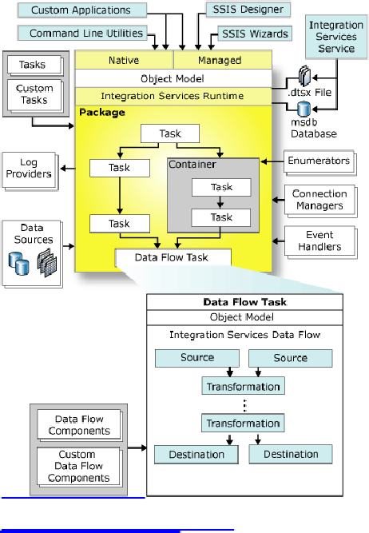

Developers who access the Integration Services object model from custom clients or write custom  
tasks or transformations can write code by using any common language runtime (CLR)  
compliant language. For more information, see Integration Services Programming.

Integration Services Service

The Integration Services service, available in SQL Server Management Studio, monitors running

Integration Services packages and manages the storage of packages.

For more information, click one of the following topics:

Integration Services Service

Introducing SQL Server Management Studio

Integration Services Object Model

5

The Integration Services object model includes managed application programming interfaces

(API) for accessing Integration Services tools, command-line utilities, and custom applications.

For more information, click one of the following topics:

Integration Services Programming

Integration Services Tools and Utilities

Integration Services Runtime

The Integration Services runtime saves the layout of packages, runs packages, and provides  
support for logging, breakpoints, configuration, connections, and transactions. The Integration  
Services run-time executables are the package, containers, tasks, and event handlers that  
Integration Services includes, and custom tasks.

For more information, click one of the following topics:

Integration Services Packages  
Integration Services Containers  
Integration Services Tasks  
Integration Services Event Handlers  
Microsoft.SqlServer.Dts.Runtime

Integration Services Data Flow

The Data Flow task encapsulates the data flow engine. The data flow engine provides the in-  
memory buffers that move data from source to destination, and calls the sources that extract data  
from files and relational databases. The data flow engine also manages the transformations that  
modify data, and the destinations that load data or make data available to other processes.  
Integration Services data flow components are the sources, transformations, and destinations that  
Integration Services includes. You can also include custom components in a data flow.

For more information, click one of the following topics:

Data Flow Task  
Data Flow Elements  
Microsoft.SqlServer.Dts.Pipeline.Wrapper

Source:http://technet.microsoft.com/en-us/library /ms141709 (SQL.90).a spx

6



Q2 Difference between Control Flow and Data Flow?

Very easy.

Q3 How would you do Logging in SSIS?

Log using the logging configuration inbuilt in SSIS or use Custom logging through Event

handlers.

Monitoring How-to Topics (Integration Services)

This section contains procedures for adding log providers to a package and configuring logging by using the SQL Server Integration Services tools that Business Intelligence Development Studio provides.

How to: Enable Logging in a Package

How to: Enable Logging in a Package

This procedure describes how to add logs to a package, configure package-level logging, and  
save the logging configuration to an XML file. You can add logs only at the package level, but the  
package does not have to perform logging to enable logging in the containers that the package  
includes.

By default, the containers in the package use the same logging configuration as their parent

container. For information about setting logging options for individual containers, see How to:

Configure Logging by Using a Saved Configuration File.

To enable logging in a package

1. In Business Intelligence Development Studio, open the Integration Services project that

contains the package you want.

2.On theSSIS menu, clickLogging.  
3.Select a log provider in the Provider type list, and then clickAdd.  
4.In theConfiguration column, select a connection manager or click <New connection> to

create a new connection manager of the appropriate type for the log provider. Depending

on the selected provider, use one of the following connection managers:

o

For Text files, use a File connection manager. For more information, seeFile

Connection Manager

o

For SQL Server Profiler, use a File connection manager.

o

For SQL Server, use an OLE DB connection manager. For more information, see

OLE DB Connection Manager.

o

For Windows Event Log, do nothing. SSIS automatically creates the log.

o

For XML files, use a File connection manager.

5. Repeat steps 3 and 4 for each log to use in the package.

Note:

A package can use more than one log of each type.

6.Optionally, select the package-level check box, select the logs to use for package-level

logging, and then click theDeta il s tab.

7.On theDetails tab, selectEvents to log all log entries, or clearEvents to select individual

events.

7



8.Optionally, clickAdvanced to specify which information to log.

Note:

By default, all information is logged.

9.On theDetails tab, clickSave. The Save As dialog box appears. Locate the folder in

which to save the logging configuration, type a file name for the new log configuration,

and then clickSave.

10.ClickOK.

11.To save the updated package, click Save Selected Items on theFile menu.

How to: Configure Logging by Using a Saved Configuration File

How to: Configure Logging by Using a Saved Configuration File

This procedure describes how to configure logging for new containers in a package by loading a

previously saved logging configuration file.

By default, all containers in a package use the same logging configuration as their parent  
container. For example, the tasks in a Foreach Loop use the same logging configuration as the  
Foreach Loop.

To configure logging for a container

1. In Business Intelligence Development Studio, open the Integration Services project that

contains the package you want.

2.On theSSIS menu, clickLogging.

3. Expand the package tree view and select the container to configure.

4.On the Providers and Logs tab, select the logs to use for the container.

Note:

You can create logs only at the package level. For more information, see How to: Enable

Logging in a Package.

5.Click theDeta il s tab and clickLoad.  
6.Locate the logging configuration file you want to use and clickOpen.  
7.Optionally, select a different log entry to log by selecting its check box in theEvent s

column. ClickAdvanced to select the type of information to log for this entry.

Note:

The new container may include additional log entries that are not available for the  
container originally used to create the logging configuration. These additional log entries  
must be selected manually if you want them to be logged.

8.To save the updated version of the logging configuration, clickSave.

9.To save the updated package, click Save Selected Items on theFile menu.

Source:http://m sdn.mi crosoft.com/en-u s/library/ms141710.a spx

How to: View Log Entries in the Log Events Window

How to: View Log Entries in the Log Events Window

8

This procedure describes how to run a package and view the log entries it writes. You can view the log entries in real time. The log entries that are written to the Log Events window can also be copied and saved for further analysis.

It is not necessary to write the log entries to a log to write the entries to the Log Events window.

To view log entries

1. In Business Intelligence Development Studio, open the Integration Services project that

contains the package you want.

2.On theSSIS menu, click Log Events. You can optionally display the Log Events window

by mapping the View.LogEvents command to a key combination of your choosing on the

Keyboard page of the Options dialog box.

3.On theDebug menu, click Start Debugging.

As the runtime encounters the events and custom messages that are enabled for logging,

log entries for each event or message are written to the Log Events window.

4.On theDebug menu, click Stop Debugging.

The log entries remain available in the Log Events window until you rerun the package,

run a different package, or close Business Intelligence Development Studio.

5.View the log entries in the Log Events window.  
6.Optionally, click the log entries to copy, right-click, and then clickCopy.  
7.Optionally, double-click a log entry, and in the Log Entry dialog box, view the details for

a single log entry.

8.In the Log Entry dialog box, click the up and down arrows to display the previous or

next log entry, and click the copy icon to copy the log entry.

9. Open a text editor, paste, and then save the log entry to a text file.

Source:

http://msdn.microsoft.com/en-us/library/ms141727.aspx

Q4 How would you do Error Handling?

its for you.

Q5 How to pass property value at Run time? How do you implement Package Configuration?

Package Configurations

SQL Server Integration Services provides package configurations that you can use to update the  
values of properties at run time. A configuration is a property/value pair that you add to a  
completed package. Typically, you create a package set properties on the package objects during  
package development, and then add the configuration to the package. When the package runs, it  
gets the new values of the property from the configuration. For example, by using a  
configuration, you can change the connection string of a connection manager, or update the value  
of a variable.

9



Package configurations provide the following benefits:

•

Configurations make it easier to move packages from a development environment to a production environment. For example, a configuration can update the path of a source file, or change the name of a database or server.

•

Configurations are useful when you deploy packages to many different servers. For  
example, a variable in the configuration for each deployed package can contain a  
different disk space value, and if the available disk space does not meet this value, the  
package does not run.

•

Configurations make packages more flexible. For example, a configuration can update

the value of a variable that is used in a property expression.

Integration Services supports several different methods of storing package configurations, such

as XML files, tables in a SQL Server database, and environment and package variables.

Each configuration is a property/value pair. The XML configuration file and SQL Server

configuration types can include multiple configurations.

The configurations are included when you create a package deployment utility for installing packages. When you install the packages, the configurations can be updated as a step in the package installation.

Note:

To become better acquainted with the concepts explained in this section, see Tutorial: Deploying

Packagesand Lesson 3: Adding Package Configurationsof Tutorial: Creating a Simple ETL

Package.

Package Configuration Types

The following table describes the package configuration types.

Type

Description

XML configuration

file

An XML file contains the configurations. The XML file can include multiple

configurations.

Environment

variable

An environment variable contains the configuration.

Registry entry

A registry entry contains the configuration.

Parent package

variable

A variable in the package contains the configuration. This configuration type

is typically used to update properties in child packages.

SQL Server tableA table in a SQL Server database contains the configuration. The table can

include multiple configurations.

XML Configuration Files

If you select the XML configuration file configuration type, you can create a new configuration  
file, reuse an existing file and add new configurations, or reuse an existing file but overwrite  
existing file content.

An XML configuration file includes two sections:

10



•

A heading that contains information about the configuration file. This element includes attributes such as when the file was created and the name of the person who generated the file.

•

Configuration elements that contain information about each configuration. This element

includes attributes such as the property path and the configured value of a property.

The following XML code demonstrates the syntax of an XML configuration file. This example

shows a configuration for theValue property of an integer variable named MyVar.

Copy Code

<?xml version="1.0"?>

<DTSConfiguration>

<DTSConfigurationHeading>

<DTSConfigurationFileInfo  
GeneratedBy="DomainName\UserName"  
GeneratedFromPackageName="Package"  
GeneratedFromPackageID="{2AF06766-817A-4E28-9878-0DE37A150648}"  
GeneratedDate="2/01/2005 5:58:09 PM"/>

</DTSConfigurationHeading>  
<Configuration ConfiguredType="Property" Path="\Package.Variables[User::MyVar].Value"  
ValueType="Int32">

<ConfiguredValue>0</ConfiguredValue>

</Configuration>

</DTSConfiguration>

Registry Entry

If you want to use a registry entry to store the configuration, you can either use an existing key or  
create a new key in HKEY_CURRENT_USER. The registry key that you use must have a value  
namedValue. The value can be a DWORD or a string.

If you select the Registry entry configuration type, you type the name of the registry key in the Registry entry box. The format is <registry key>. If you want to use a registry key that is not at the root of HKEY_CURRENT_USER, use the format <registry key\registry key\...> to identify the key. For example, to use the MyPackage key located in SSISPackages, type

SSISPackages\MyPackage.

SQL Server

If you select the SQL Server configuration type, you specify the connection to the SQL Server database in which you want to store the configurations. You can save the configurations to an existing table or create a new table in the specified database.

The following SQL statement shows the default CREATE TABLE statement that the Package

Configuration Wizard provides.

Copy Code

CREATE TABLE [dbo].[SSIS Configurations]

(ConfigurationFilter NVARCHAR(255) NOT NULL,

ConfiguredValue NVARCHAR(255) NULL,

11



PackagePath NVARCHAR(255) NOT NULL,  
ConfiguredValueType NVARCHAR(20) NOT NULL  
)The name that you provide for the configuration is the value stored in theConfigurationFilter

column.

Direct and Indirect Configurations

Integration Services provides direct and indirect configurations. If you specify configurations  
directly, Integration Services creates a direct link between the configuration item and the package  
object property. Direct configurations are a better choice when the location of the source does not  
change. For example, if you are sure that all deployments in the package use the same file path,  
you can specify an XML configuration file.

Indirect configurations use environment variables. Instead of specifying the configuration setting  
directly, the configuration points to an environment variable, which in turn contains the  
configuration value. Using indirect configurations is a better choice when the location of the  
configuration can change for each deployment of a package.

http://msdn.microsoft.com/en-us/library/ms141682.aspx

Q6 How would you deploy a SSIS Package on production?

1. Create deployment utility by setting its property as true .

2. It will be created in the bin folder of the solution as soon as package is build.

3. Copy all the files in the utility and use manifest file to deply it on the Prod.

Q7 Difference between DTS and SSIS?

Every thing except both are product of Microsoft :-)

Q8 What are new features in SSIS 2008?

http://sqlserversolutions.blogspot.com/2009/01/new-improvementfeatures-in-ssis-2008.html

Q9 How would you pass a variable value to Child Package?

http://sqlserversolutions.blogspot.com/2009/02/passing-variable-to-child-package-from.html

How to: Use Values of Parent Variables in Child Packages

New: 5 December 2005

This procedure describes how to create a package configuration that uses the parent variable  
configuration type to enable a child package that is run from a parent package to access a variable  
in the parent.

It is not necessary to create the variable in the parent package before you create the package  
configuration in the child package. You can add the variable to the parent package at any time,  
but you must use the exact name of the parent variable in the package configuration. However,  
before you can create a parent variable configuration, there must be an existing variable in the  
child package that the configuration can update. For more information about adding and  
configuring variables, see How to: Add a Variable to a Package Using the Variables Window.

12



The scope of the variable in the parent package that is used in a parent variable configuration can be set to the Execute Package task, to the container that has the task, or to the package. If multiple variables with the same name are defined in a package, the variable that is closest in scope to the Execute Package task is used. The closest scope to the Execute Package task is the task itself.

To add a variable to a parent package

1. In Business Intelligence Development Studio, open the Integration Services project that

contains the package to which you want to add a variable to pass to a child package.  
2. In Solution Explorer, double-click the package to open it.  
3. In SSIS Designer, to define the scope of the variable, do one of the following:

o

To set the scope to the package, click anywhere on the design surface of the

Control Flowtab.

o

To set the scope to a parent container of the Execute Package task, click the

container.

o

To set the scope to a parent container of the Execute Package task, click the task.

4. Add and configure a variable.

Note:

Select a data type that is compatible with the data that the variable will store.

5.To save the updated package, click Save Selected Items on theFile menu.

To add a variable to a child package

1. In Business Intelligence Development Studio, open the Integration Services project that

contains the package to which you want to add a parent variable configuration.

2. In Solution Explorer, double-click the package to open it.

3.In SSIS Designer, to set the scope to the package, click anywhere on the design surface of

the Control Flow tab.

4. Add and configure a variable.

Note:

Select a data type that is compatible with the data that the variable will store.

5.To save the updated package, click Save Selected Items on theFile menu.

To add a parent package configuration to a child package

1. If it is not already open, open the child package in Business Intelligence Development

Studio.

2.Click anywhere on the design surface of the Control Flow tab.  
3.On theSSIS menu, click Package Configurations.  
4.In the Package Configuration Organizer dialog box, select Enable package

configuration, and then click Add.

5.On the welcome page of the Package Configuration Wizard, clickNext.

6.On the Select Configuration Type page, in the Configuration type list, selectParent

package variable and do one of the following:

o

Select Specify configuration settings directly, and then in the Parent variable  
box, provide the name of the variable in the parent package to use in the  
configuration.

Important:

Variable names are case sensitive.

13

o

Select or Configuration location is stored in an environment variable, and then  
in the Environment variable list, select the environment variable that contains  
the name of the variable.

7.ClickNext.

8.On the Select Target Property page, expand theVariable node, and expand the

Properties node of the variable to configure, and then click the property to be set by the

configuration.

9.ClickNext.

10. On the Completing the Wizard page, optionally, modify the default name of the

configuration and review the configuration information.

11.ClickFini sh to complete the wizard and return to the Package Configuration Organizer

dialog box.

12.In the Package Configuration Organizer dialog box, theConfiguration box lists the new

configuration.

13.ClickClose.

http://technet.microsoft.com/en-us/library/ms345179(SQL.90).aspx

Q10 What is Execution Tree?

Execution Trees

Execution trees demonstrate how your package uses buffers and threads. At run time, the data  
flow engine breaks down Data Flow task operations into execution trees. These execution trees  
specify how buffers and threads are allocated in the package. Each tree creates a new buffer and  
may execute on a different thread. When a new buffer is created such as when a partially  
blocking or blocking transformation is added to the pipeline, additional memory is required to  
handle the data transformation; however, it is important to note that each new tree may also give  
you an additional worker thread.

Examine the execution trees in the example depicted in Figure 1 and Table 1 where two Employee datasets are combined together and then aggregated to load into a common destination table.

14

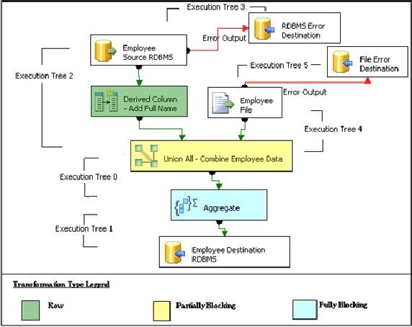

Figure 1: Example package  
Note:Execution trees are listed in the table in the order that they execute.  
Table 1: Execution trees defined

Execution Tree

Enumeration

Description

begin execution tree

2

output "OLE DB

Source Output" (27)

input "Derived

Column Input" (172)

output "Derived  
Column Output"  
(173)

input "Union All

Input 1" (411)

output "Derived

In Execution Tree 2, SSIS reads data from the Employee OLE DB Source into  
the pipeline, a Derived Column transformation adds another column, and  
SSIS passes data to the Union All transformation. All of the operations in  
this execution tree use the same buffer; data is not copied again once it is  
read into the OLE DB Source Output.

15